**PIZZA SALES SQL QUERIES**

**A. KPI’s**

**1. Total Revenue:**

select sum(total_price) AS Total_Revenue from pizza_data;

***Output***

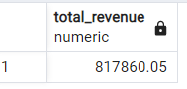

**2. Average Order Value**

select sum(total_price)/count(distinct order_id) as Average_Order_Value from pizza_data;

***Output***

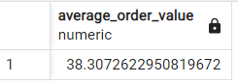

**3. Total Pizzas Sold**

select sum(quantity) as Total_Pizza_Sold from pizza_data;

***Output***

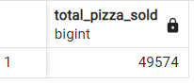

**4. Total Orders**

select count( distinct order_id) as Total_order from pizza_data;

***Output***

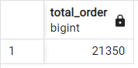

**5. Average Pizzas Per Order:**

select cast(cast(sum(quantity) as decimal(10,2))/cast(count(distinct order_id) as decimal(10,2)) as decimal(10,2)) as Avg_pizza_sold_per_order from pizza_data;

***Output***

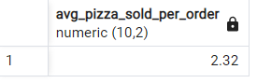

**B. Daily Trend for Total Orders**Select to_char(order_date, 'Day') as order_day,

count(distinct order_id) as Total_order from pizza_data

group by order_day;

***Output:***

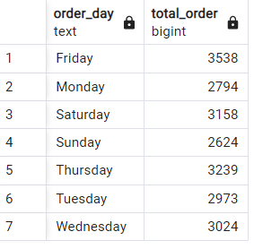

**C. Monthly Trend for Orders**

Select to_char(order_date, 'Month') as Month_order,

count(distinct order_id) as Total_order from pizza_data

group by Month_order

order by Total_order DESC;

***Output***

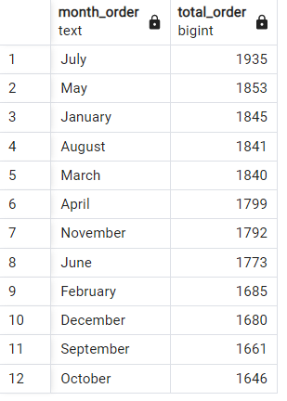

**D. % of Sales by Pizza Category**

select pizza_category, sum(total_price) as Total_Sales,

sum(total_price) * 100/(select sum(total_price) from pizza_data) As PCT

from pizza_data

group by pizza_category;

***Output***

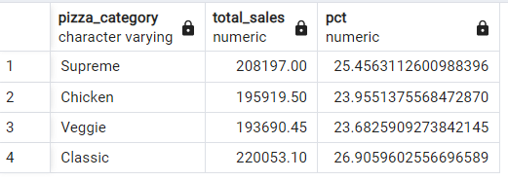

**E. % of Sales by Pizza Size**

select pizza_size, sum(total_price) as Total_Sales,

cast(sum(total_price) * 100/ (select sum(total_price) from pizza_data) as decimal(10,2)) as PCT

from pizza_data

group by pizza_size

order by PCT desc;

***Output***

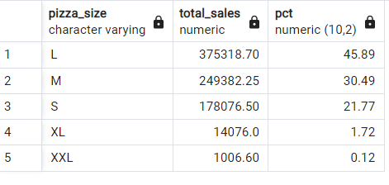

**F. Total Pizzas Sold by Pizza Category**

select pizza_category, sum(quantity) as total_pizza_sold

from pizza_data

group by pizza_category

order by total_pizza_sold desc;

***Output***

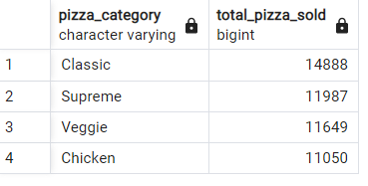

**G. Top 5 Pizzas by Revenue**

select pizza_name,

sum(total_price) as Revenue

from pizza_data

group by pizza_name

order by Revenue desc limit 5;

***Output***

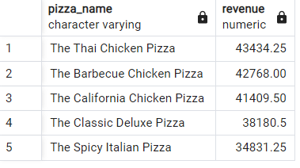

**H. Bottom 5 Pizzas by Revenue**

select pizza_name,

sum(total_price) as Revenue

from pizza_data group by pizza_name order by Revenue asc limit 5;

***Output***

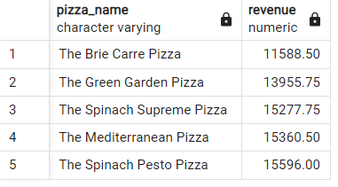

**I. Top 5 Pizzas by Quantity**

select pizza_name,

sum(quantity)as Total_Quantity

from pizza_data

group by pizza_name

order by Total_Quantity desc limit 5;

***Output***

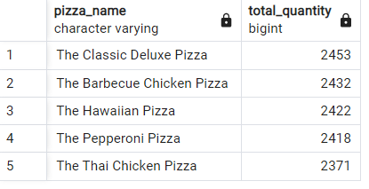

**J. Bottom 5 Pizzas by Quantity**

select pizza_name,

sum(quantity)as Total_Quantity

from pizza_data

group by pizza_name

order by Total_Quantity asc limit 5;

***Output***

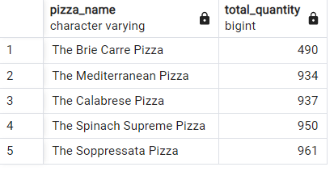

**K. Top 5 Pizzas by Total Orders**

select pizza_name,

count(distinct order_id) as Total_order

from pizza_data

group by pizza_name

order by Total_order desc limit 5;

***Output***

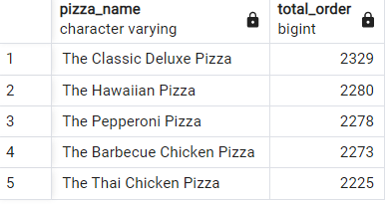

**L. Borrom 5 Pizzas by Total Orders**

select pizza_name,

count(distinct order_id) as Total_order from pizza_data

group by pizza_name order by Total_order limit 5;

***Output***

